Azure Fundamentals: Module 1, Lesson 1  
Activating Your Azure Pass and Using the Azure Portal Lab

## Overview

Microsoft Azure has a large range of services that make it ideal to introduce cloud computing. Additionally, Microsoft gives students and educators free Azure Passes that do not require the entry or use of a credit card.

Activating your Azure Pass is simple and allows you to get started exploring Azure without worrying about the cost. The Azure Pass you should have been given by your professor requires a Microsoft account. If you already have a Microsoft account and it has never been used with an Azure Pass, you can use your existing Microsoft account. If you don't have a Microsoft account, or if you do but it has been used with an Azure Pass in the past, then you will create a new Microsoft account. Microsoft accounts are free and provide access to a wide range of Microsoft services, including Azure.

The entry point to Azure is the Azure Portal, which you will become familiar with as you work through the labs.

## Objectives

In this hands-on lab you will learn how to:

* Activate your Azure Pass
* Log in to Azure with a Microsoft account
* View the Azure subscriptions associated with your Microsoft account
* View billing information in the Azure Portal
* Switch between the Azure Portal and the Classic Portal

## Prerequisites

The following are required to complete this hands-on lab:

* An Azure Pass activation code (If you do not have one, please see the instructor.)
* A web browser

Exercises

This hands-on lab includes the following exercises:

* Exercise 1: Get a Microsoft Account
* Exercise 2: Activate your Azure Pass
* Exercise 3: Access the Azure portal and view subscription and billing information

## Exercise 1: Get a Microsoft Account

When you log in to the Azure Portal, you doing so using a Microsoft account. A given account can have multiple Azure subscriptions associated with it. When you consume Azure services through the portal — when, for example, you store data in a storage account or deploy a high-performance computing (HPC) cluster — those services are billed against one of the subscriptions associated with your account.

Currently, you can only use an Azure Pass with a given Microsoft account one time. If you already have a Microsoft account and are certain that it that has never been used with an Azure Pass, then you can skip this exercise and proceed to Exercise 2. If you don't have a Microsoft account, or if you do but aren't sure whether it has ever been used with an Azure Pass, then follow the steps below to create a new Microsoft account.

1. Start a **private or incognito session** in the browser of your choice. Here are instructions for doing so in major browsers.

* Google Chrome on all operating systems
  + Start Chrome
  + Click the **Mac HD :Users:marykatereid:Downloads:1. Introduction 2:Images:chrome-menu.png** button in the upper-right corner
  + Select **New Incognito Window**
* Mozilla Firefox on all operating systems
  + Start Firefox
  + Click the Mac HD :Users:marykatereid:Downloads:1. Introduction 2:Images:chrome-menu.png button in the upper-right corner
  + Select **New Private Window**
* Apple Safari on OS X
  + Start Safari
  + Select **File > New Private Window**
* Microsoft Edge on Windows 10
  + Start Microsoft Edge
  + Click the Mac HD :Users:marykatereid:Downloads:1. Introduction 2:Images:edge-mode-actions.png button in the upper-right corner
  + Select **New InPrivate window**
* Internet Explorer on Windows
  + Start Internet Explorer
  + Click the gear icon in the upper-right corner
  + Select **Safety > InPrivate Browsing**

1. In the private browsing window, navigate to the Microsoft account sign-up page at [https://signup.live.com](https://signup.live.com/).

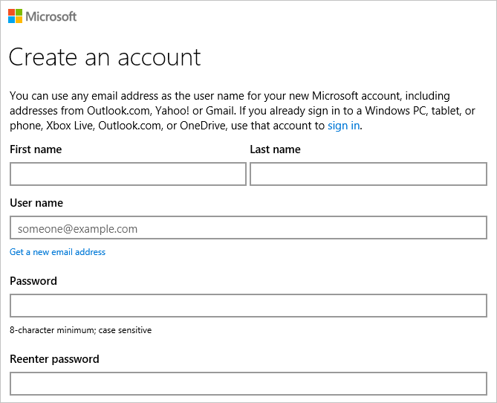

*Creating a new Microsoft account*

1. Type in the information requested and at the bottom of the page, click the **Create account** button. *Remember the user name and password you entered* because you will need them to log in to the Azure Portal.

You can use any e-mail address you'd like as the user name for your new Microsoft account, including the .edu address provided by your school, but you can't use an e-mail address that has *already* been used to create a Microsoft account. If you need a new e-mail address, click **Get a new email address** under the **User name** box near the top of the form.

1. If you're prompted to provide further information or perform additional actions, follow the instructions provided to finish creating the Microsoft account.

Now that you have a Microsoft account, you can proceed to activate your Azure Pass.

## Exercise 2: Activate your Azure Pass

In this exercise, you will use the code you were given by your professor and associate it with your Microsoft account. There are different opportunities for acquiring an Azure pass, for more information about Azure’s service offerings take a look at the following links:

•         [Microsoft Azure Free Trial](https://azure.microsoft.com/en-us/free/)

•         [Microsoft Imagine](https://www.dreamspark.com/student/default.aspx)

•         [Visual Studio Dev Essentials](https://www.visualstudio.com/en-us/products/visual-studio-dev-essentials-vs.aspx)

•         [AzureU](https://www.microsoftazurepass.com/azureu)

•         [Azure for Research](http://research.microsoft.com/en-us/projects/azure/default.aspx)

1. Open your Web browser and navigate to <https://www.microsoftazurepass.com>. Select a country from the drop-down list labeled **Please Select Country**, and type the activation code you were given into the box underneath the drop-down list. Then click the **Submit** button.

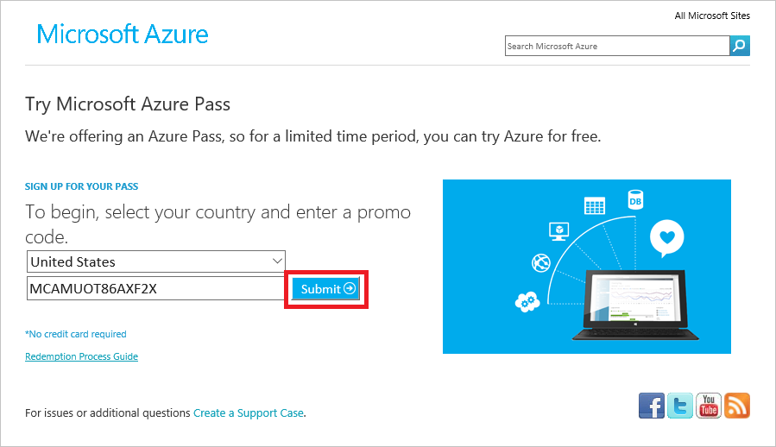

1. If your activation code is accepted, you will be asked to sign in using your Microsoft account. Click the Sign in button.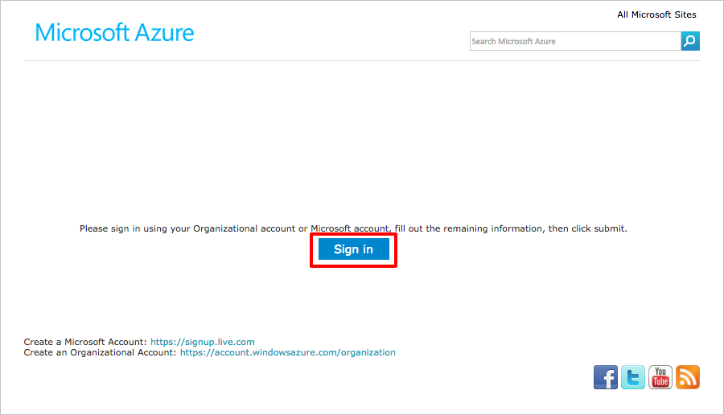
2. What happens next will vary depending on how many and what types of Microsoft accounts you have. The goal is to sign in using the credentials for the new Microsoft account you created in Exercise 1, or for your existing Microsoft account if you skipped Exercise 1. Ultimately, you will probably be asked to enter the user name and password for that account. Type them in and click the Sign in button. 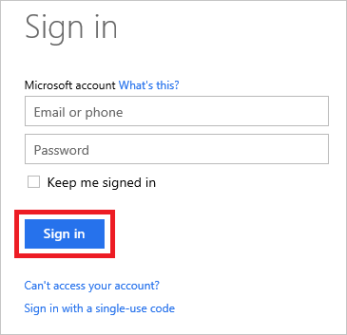
3. You will now be returned to the Azure Pass site and asked to verify your first and last names. Confirm that they are correct and click the Submit button.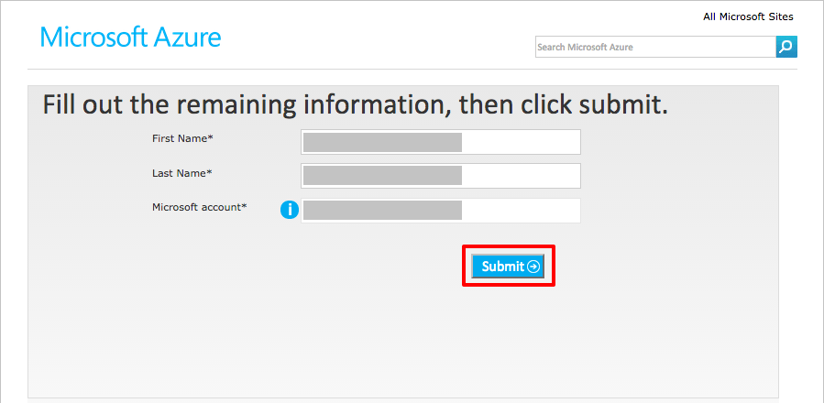
4. Click the Activate button to activate your Azure Pass.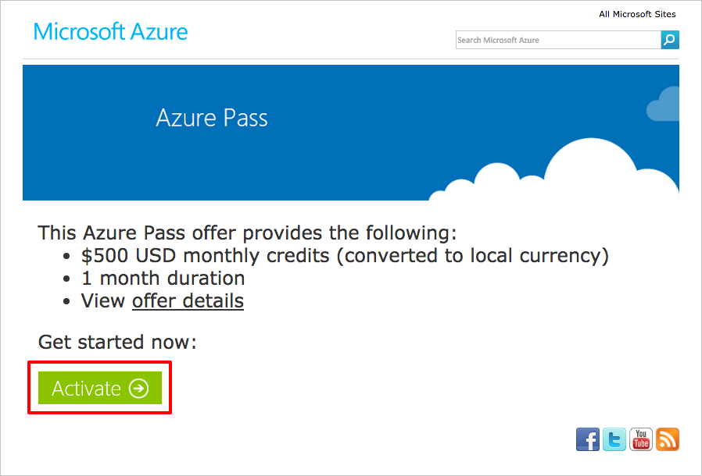
5. After a few moments, you will be asked to provide additional information, including a contact phone number. Enter your phone number and check the I agree to the subscription agreement, offer details, and privacy statement box. Then click the Sign up button and do not close the browser as it can take several minutes to activate the Azure Pass.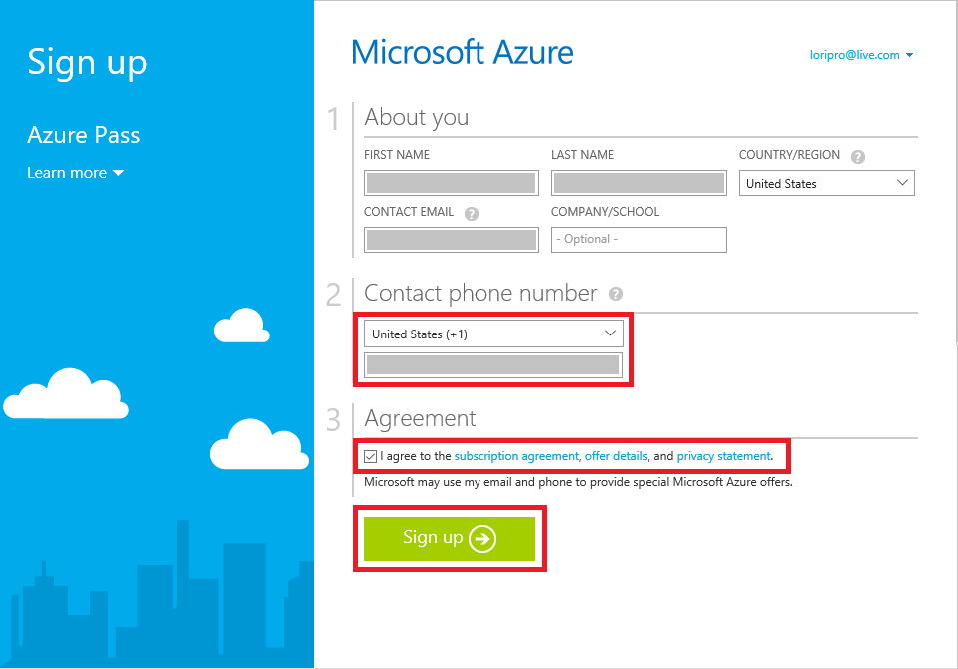
6. After several minutes, you'll be told "Your subscription is ready for you!" Do not click the Start managing my service button. Instead, close the browser window.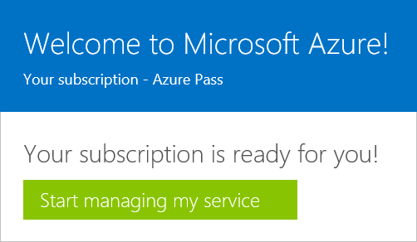
7. Open up a new browser window and navigate to the Azure Portal at https://portal.azure.com. If you're asked to choose which Microsoft account to log in with, select the one that you used to activate your Azure Pass. If you're asked to enter a user name and password for that account, do so. Once you're logged in, the portal will appear in your browser.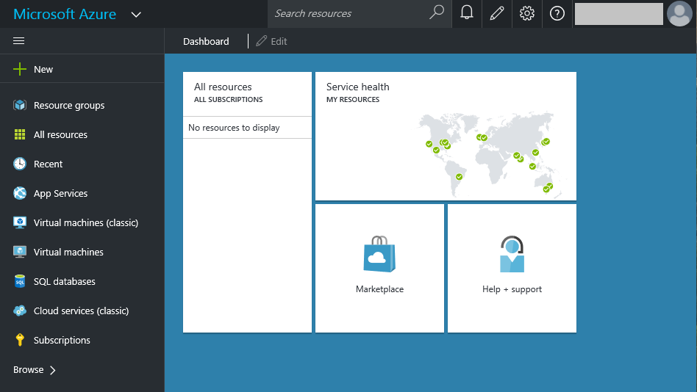

Now let's confirm that your Azure Pass was activated and associated with your Microsoft account.

## Exercise 3: Run and debug the application

In this exercise, you will learn how to list the subscriptions associated with your Microsoft account in the Azure Portal, and how to view usage data regarding those accounts so you can keep track of how much of your Azure Pass credit is left. Keep in mind that you can always reach the Azure Portal directly by navigating to https://portal.azure.com. For the Classic Portal, the address is <https://manage.windowsazure.com>.

1. If you are not in the Azure Portal, navigate to it now at <https://portal.azure.com>. If you're prompted to log in with a Microsoft account, specify the Microsoft account you used to activate your Azure Pass in Exercise 2.
2. Click Subscriptions in the ribbon on the left side of the page.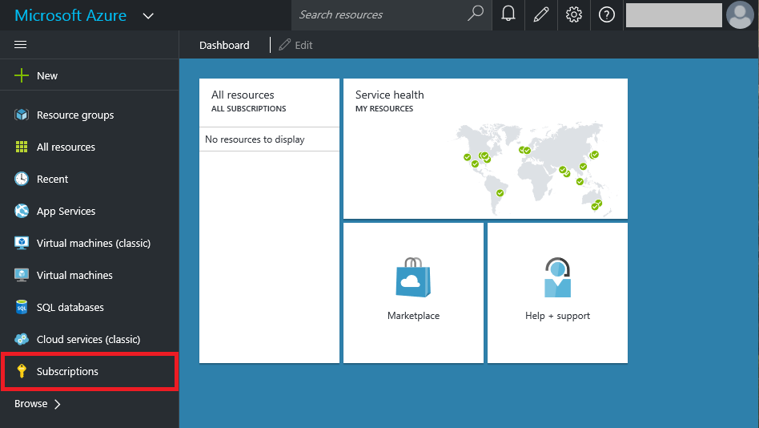
3. Confirm that Azure Pass appears among the list of subscriptions associated with your account, and that the subscription status is Active. Then click Azure Pass or Free Trial depending on which free subscription you have.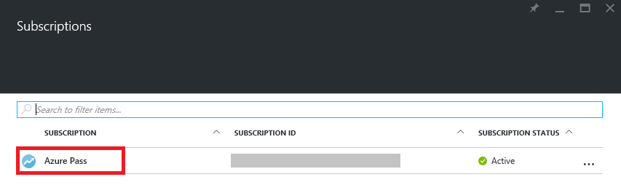 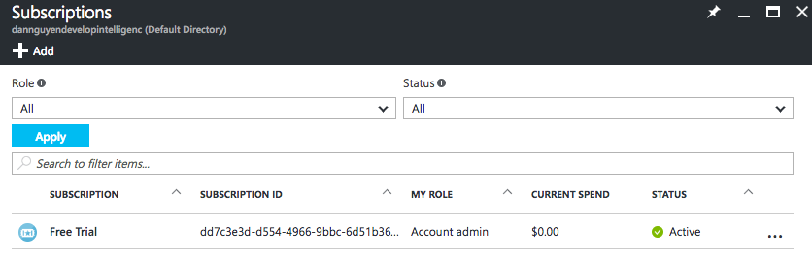

Don't be concerned if there are several Azure accounts associated with your subscription. What's important is that Azure Pass or your free subscription you just signed up for is one of them.

1. A new blade — that is, a window within the browser window — opens in the portal showing usage data and billing information for your Azure Pass. Since you just activated the subscription, there will probably be no charges listed. However, you can check back here from time to time to keep track of the charges

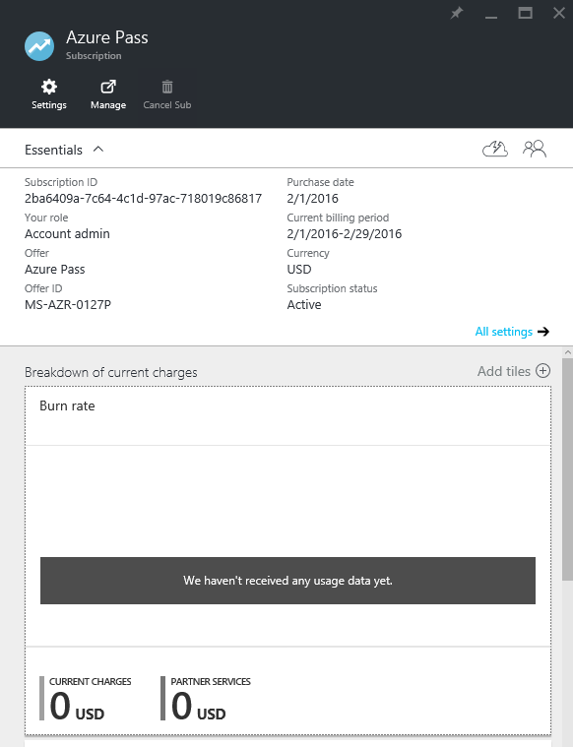

1. Most of the work you do with Azure will be done through the Azure Portal. But at times, you'll need to use the Classic Portal. To go to the Classic Portal, point your browser to <https://manage.windowsazure.com>.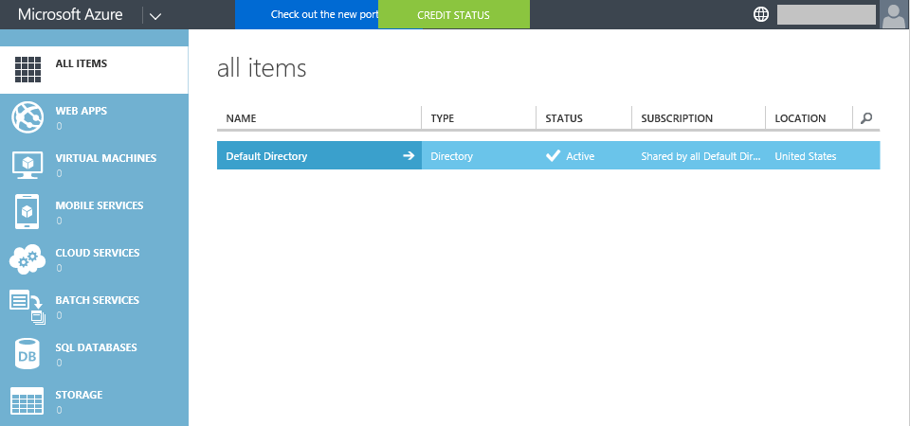
2. To quickly switch from the Classic Portal to the Azure Portal, click your user name in the upper-right corner of the page and select Switch to the new Azure Portal.

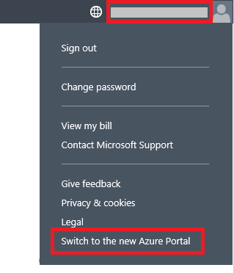

Now you know how to switch between portals, as well as how to view usage data for your Azure Pass subscription.

## Summary

In this hands-on lab, you learned how to:

* Activate an Azure Pass
* Log in to Azure with a Microsoft account
* View the Azure subscriptions associated with your Microsoft account
* View billing information in the Azure Portal
* Switch between the Azure Portal and the Classic Portal

The portal will be your home for everything Azure and your gateway for using the cloud to aid your research.